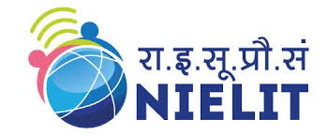
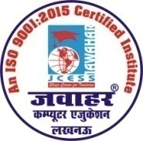
DOEACC (NIELIT) से ‘O’ Level/CCC कोर्स हेतु मान्यता प्राप्त संस्थान

PAPER NAME:-M4.3-R4 (INTRODUCTION TO ICT RESOURCES)
JAWAHAR COMPUTER EDUCATION®
(A Unit of: Jawahar Computer Prashikshen Seva Samiti)
(An ISO 9001:2015 Certified Institute)

Important Topic

SHORT NOTES
- Antivirus, Virus, DVD, File system
- Backup and Restore
- Networking(F-disk command)
- UPS and POST

DIFFERENCE BETWEEN
- Straight through v/s Cross over cable
- BIOS v/s CMOS
- Router v/s Bridge
- Impact v/s Non impact

LONG ANSWER
- Transmission mode (Guided, Unguided media)
- IP address and its classes(IPV4 and IPV6)
- Network topology(Star, Mesh, Ring)
- Networking devices (Hub, Switch, Gateway, Bridge)
- File compression(PKZIP,WINZIP)
- TCP/IP model , OSI model
- Firewall, user creation
- Utilities - Disk cleanup, Defragmentation, Scan disk
- Simplex , Full duplex
- Change date and time.

EXTRA QUESTIONS
- Booting process
- Backup and Restore
- MAC address
- File sharing in workbook
- Write in CD using Nero software
- About motherboard

H.O. : A-873/1, Sector – I, Near Sai Temple, Khazana Chauraha, Aashiyana, Lucknow
B.O. : G-13, Sector – G, LDA Colony, Kanpur Road, Lucknow, Uttar Pradesh
Ph. 0522-4002833, Mobile: 9807961233, 9335926583

