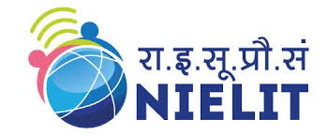
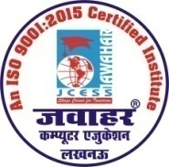
Paper Name M2-R4(Internet Technology and Web Design)
DOEACC (NIELIT) से ‘O’ Level/CCC कोर्स हेतु मान्यता प्राप्त संस्थान
JAWAHAR COMPUTER EDUCATION®
(A Unit of: Jawahar Computer Prashikshen Seva Samiti)
(An ISO 9001:2015 Certified Institute)

Important Topic

Differences Between
- Public Key v/s Private Key
- Slip v/s PPP
- Peer to Peer v/s Client Server
- Internet v/s WWW
- SMTP v/s POP3 v/s IMAP4

Short Notes
- Structure of Email
- Search engine
- IRC, PKI, URL, FDDI, CGI, MIME, ISDN, DNS.
- Java script , Java
- Email encryption
- Digital Signature Electronic Payment
- Simplex, Half Duplex, Full duplex
- E-Commerce

Long Answer
- Meta Search Engine
- LAN< MAN, WAN
- Firewall & its Type
- Switches
- OSI Model, TCP/IP Model
- Networking Devices (HUB, Switch, Router)
- Network Topology (Bus, Star, Mesh)
- IP address and its classes
- Web hosting and publishing

Web Design
- How to make an image in HTML?
- How to print hello using Java script?
- Form creation, table creation, frameset.
H.O. : A-873/1, Sector – I, Near Sai Temple, Khazana Chauraha, Aashiyana, Lucknow
B.O. : G-13, Sector – G, LDA Colony, Kanpur Road, Lucknow, Uttar Pradesh
Ph. 0522-4002833, Mobile: 9807961233, 9335926583
Email Id: jcesspuneet@gmail.com

